PHASE 6: Testing, Validation & Security
The objective of this phase is to verify that the developed solution works as expected, satisfies the functional requirements, and follows basic security and access control practices.
It validates the complete workflow, checks data accuracy, and ensures that ticket information can be accessed or modified only by authorized users.

Data Validation Checks
- Verify that mandatory fields are captured correctly.
- Confirm that the auto number is generated without duplication.
- Confirm that Category and Subcategory values are stored correctly.
- Verify that reference fields correctly resolve to the user and group tables.

Activity 1: Testing & Validation

Test Scenario 1
- Enter a Caller Name.
- Short Description: WiFi not working in library
- Save the form.
- Reload the form.
- The system should automatically fill:
- Category → Network
- Subcategory → WiFi
- An email is sent to the caller's email ID.
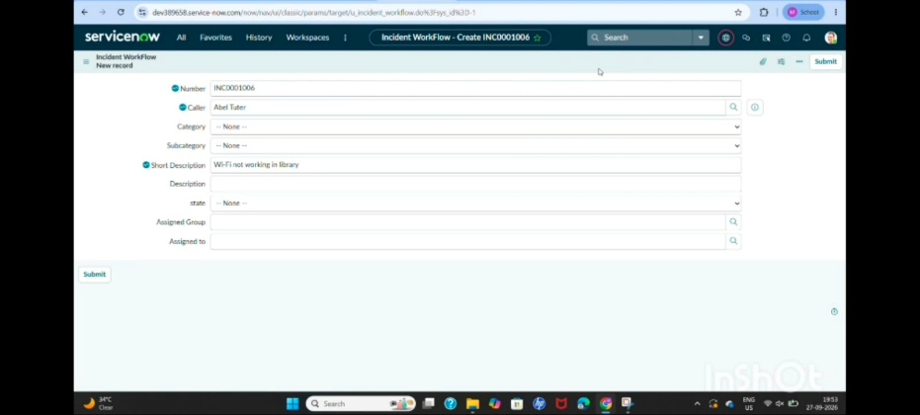

Activity 2: Verify Email Notification
- Open All menus → Search for Email.
- Under System Logs , select Emails .
- Search using the specified email subject.
- Open the email record and, under Related Links , select Preview Mail .
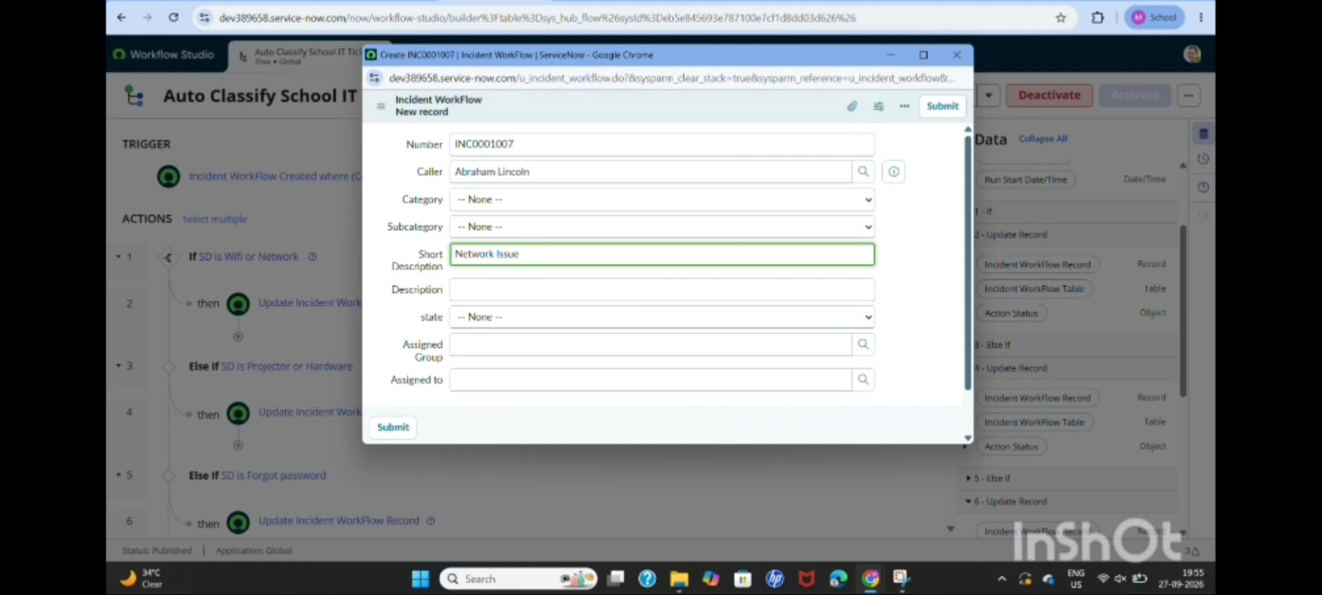

Activity 3: Test Scenario 2
- Enter a Caller Name.
- Short Description: Projector not turning on .
- Save the form.
- Reload the form.
- The system should automatically fill:
- Category → Hardware
- Subcategory → Projector
- An email is then sent to the caller's email ID.

